Lab 1: Input, Processing, and Output
This lab accompanies Chapter 2 of Starting Out with Programming Logic & Design.

Name: _____________Joy Chudasama______________

Lab 1.1 – Algorithms

This lab requires you to think about the steps that take place in a program by writing algorithms. Read the following program prior to completing the lab.
Critical Review

An algorithm is a set of well-designed logical steps that must take place in order to solve a problem.

The flow the algorithm takes is sequential. For example, before you process calculations, all data needed should be retrieved.

Help Video: Double click the file to view video

Write a program that will take in basic information from a student, including student name, degree name, number of credits taken so far, and the total number of credits required in the degree program. The program will then calculate how many credits are needed to graduate. Display should include the student name, the degree name, and credits left to graduate.

Step 1: Examine the following algorithm. (Reference: Designing a Program, page 31).

- Get the student name.
- Get the degree program name.
- Subtract the number of credits taken so far from the required credits for the degree.
- Get the number of credits required for the degree program.
- Get the number of credits the student has taken so far.
- Display the input information in Step 1 and 2.
- Display the calculated information.

Step 2: What logic error do you spot and how would you fix it?
Just replace step 5 to step 3.

Step 3: What steps require user interaction (Ex: user must type in some input)?
Getting “Student name”, “Degree program name”,” The number of credits require
d for the degree program” and “The number of credits the student has taken so far” must need user interaction.
Lab 1.2 – Pseudocode
Critical Review

Pseudocode is an informal language that has no syntax rules and is not meant to be compiled or executed.

The flow the program takes is sequential. For example, before you ask for input, you should display what information you want from the user.

//Comments are done by putting two forward slashes before the lines you want to //document. Comments are used to explain code.

Variables are named storage locations.

"Declare" is the keyword used before naming a variable. Data types are: Real for decimal numbers, Integer for whole numbers, and String for a series of characters.

Follow the rules for naming variables: (1) must be one word, no spaces, (2) usually no punctuation characters, only letters and numbers, and (3) name cannot start with a number.

"Display" is the keyword used to print something to the screen. Any information needed to be displayed to the user should be put inside quotation marks such as Display “This is how you print something to the screen”. When using display to print both a string and the value of a variable, a comma is used, such as Display “Here is the average”, average.

"Input" is the keyword used to get the user to enter data. The data value entered by the user will be placed in the variable that follows the keyword input such as Input variableName.

"Set" is the keyword used before a calculation. Standard math operators are used, such as + - * / MOD ^. Operators can be combined in one calculation, but it is wise to group expressions together using parentheses. Remember the order of operations. Some examples are Set sale = price – discount and Set average = (test1 + test2 + test3) / 3.

Help Video: Double click the file to view video

This lab requires you to think about the steps that take place in a program by writing pseudocode. Read the following program prior to completing the lab.

Write a program that will take in basic information from a student, including student name, degree name, number of credits taken so far, and the total number of credits required in the degree program. The program will then calculate how many credits are needed to graduate. Display should include the student name, the degree name, and credits left to graduate.

Step 1: This program is most easily solved using just five variables. Identify potential problems with the following variables declared in the pseudocode. Assume that the college has the ability to offer half credits. (Reference: Variable Names, page 39-40).

Variable Name | Problem (Yes or No) | If Yes, what’s wrong?
Declare Real creditsTaken | No
Declare Real credits Degree | Yes | There should be no space between credits and degree
Declare Int creditsLeft | No
Declare Real studentName | Yes | “Real” is for numbers so there should be “String”
Declare String degreeName | No

Step 2: Complete the pseudocode by writing the two missing lines. (Reference: Prompting the User, page 42).

Display “Enter student name.”
Input studentName
Display “Enter degree program.”
Input degreeName
Display “Enter the credits of degree:”
Input creditsDegree
Display “Enter the number of credits taken so far.”

Step 3: What two things are wrong with the following calculation? (Reference: Variable Assignment and Calculations, page 43).

creditsLeft = creditsTaken – creditsDegree

creditsLeft = creditsDegree - creditsTaken

Step 4: Write the exact output you would expect from the following line of code if the user of the program enters “Bill Jones”. (Reference: Displaying Items, page 40 – 41).

Display “The student’s name is “, studentName
The student’s name is Bill Jones

Step 5: Write the exact output you would expect from the following line of code if the user of the program enters a degree that is 63 credits in total and they have taken 40 credits. (Reference: Displaying Items, page 40 – 41).

Display “This program requires “, creditsDegree, “ credits and they have taken “, creditsTaken, “ so far.”
This program requires 63 credits and they have taken 40 so far.

Step 6: Complete the following pseudocode to solve the programming problem.

- //This program takes in student information and calculates
- //how many credits the student has left before graduation.
- //Information is then printed to the screen.

- //Declare variables
- Declare Real creditsTaken
- Declare Real creditsDegree
- Declare Real creditsLeft
- Declare String studentName
- Declare String studentsDegree

- //Ask for user input
- Display “Enter student name.”
- Input studentName
- Display “Enter the degree program”
- Input degreeProgram
- Display “Enter credits degree”
- Input creditsDegree
- Display “Enter credits taken”
- Input creditsTaken
- //Calculate remaining credits
- creditsLeft = creditsDegree - creditsTaken
- //Display student name, degree program, and credits left.
- Display “The student’s name is “+studentName
- Display “The degree program is”+degreeProgram
- Display “Credits left to graduate”+creditsLeft

Lab 1.3 – Flowcharts
Critical Review

A flowchart is a diagram that graphically depicts the steps that take place in a program. Symbols are used to depict the various steps that need to happen within a program. Flow lines are used between the symbols to indicate the flow of the program.

Ovals are used as terminal symbols, which indicate a start and stop to a program.

Parallelograms, the data symbol, are used for input and display statements.

Rectangles, the process symbol, are used for calculations and variable declarations.

On page connectors are used to link a flowchart that continues on the same page. The connecting system starts with the letter A, whereas A would appear in the two connectors that show the flow.

The statements inside the data and the process symbols can be written similarly to the statements used in pseudocode.

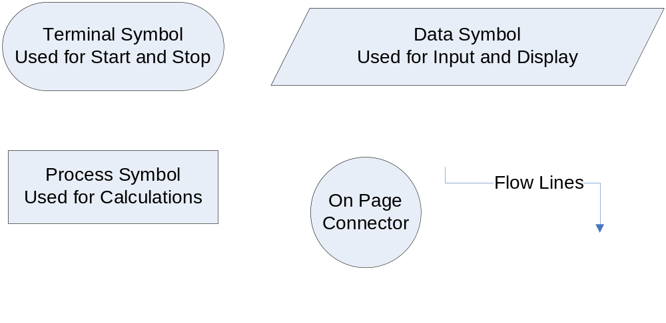
Help Video: Double click the file to view video

This lab requires you to think about the steps that take place in a program by designing a flowchart. While designing flowcharts can be done with paper and pencil, one mistake often requires a lot of erasing. Therefore, a flowcharting application such as Raptor or Visio should be used. This lab will give you a brief overview of Raptor. Read the following program prior to completing the lab.

Write a program that will take in basic information from a student, including student name, degree name, number of credits taken so far, and the total number of credits required in the degree program. The program will then calculate how many credits are needed to graduate. Display should include the student name, the degree name, and credits left to graduate.

Step 1: Start Raptor; notice the Raptor screen. This window is your primary tool for creating a flowchart. Prior to adding symbols, save your document by clicking on File and then Save. Select your location and save the file as Lab 1-3. The .rap file extension will be added automatically.

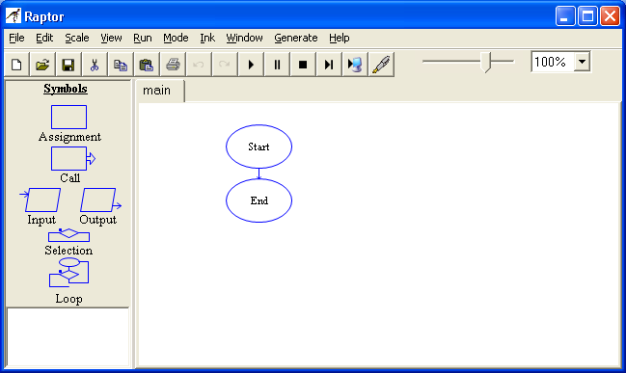

Step 2: Notice the MasterConsole screen. This window is used to show your program output once your flowchart is completed. The Clear button will clear the console to view a fresh run of your program.

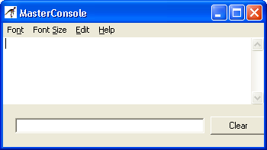
Step 3: Return to the Raptor screen to begin adding symbols into your flowchart. Your flowchart should follow the pseudocode in Lab 1-2, Step 6. While a rectangle is normally used for declaring variables, there is no easy way to do this in Raptor. Since this is an important part of flowcharting, we will do this using a comment box. To do this, Right-Click on the Start symbol and select Comment. In the Enter Comment box, type the variables your program will need. Below is a start to how it should look.

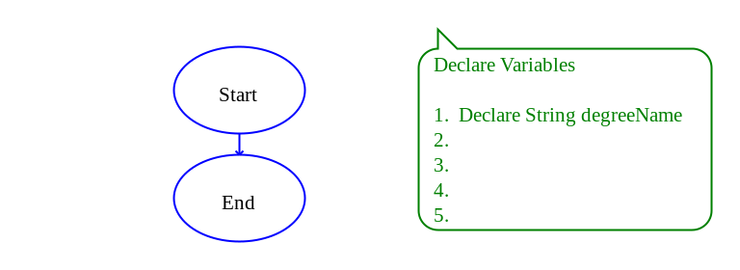

Step 4: The next step in your flowchart should be to ask for user input. Click the Input Symbol on the Left and Drag and Drop to the flow line between Start and Stop. Double Click on the Input Symbol to begin entering information. Enter Enter student name in the top box. Enter studentName in the variable box. Below is how it should look.

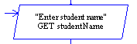

Step 5: Continue the Step 4 directions for all your input statements, changing each Input symbol to reflect the appropriate user interaction.

Step 6: The next step in your flowchart is to process any calculations that exist. Click on the Assignment symbol and drag it to the flow line between the last input statement and the end symbol. Double click on the Assignment symbol to enter your code. In the Set box, put the name of your storage variable. In the To box, put the expression part of your formula. Below is how it should look.

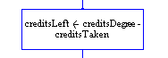

Step 7: The next step in your flowchart is to display the requested output to the screen. Click the Output symbol and drag it to the flow line between the assignment statement and the end symbol. Double click on the Output symbol to enter your code. Under Output Type, select Output Expression since we want to display both a sentence and the contents of a variable. In the box, type "Student name is " + studentName. Below is how it should look once you click Done.

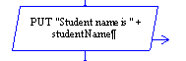

Step 8: Continue the Step 7 directions for all your output statements, changing each Output symbol to reflect the appropriate requested output information.

Step 9: Once your flowchart is complete, click on Run and then Execute to Completion on the Raptor menu. Follow the flow of your program to see if it processes properly. Your Master Console window should show output similar to

Student name is Bill Jones
The degree program is Computer Programming
Credits left to graduation is 39
----Run finished----

Step 10: The final step is to insert your finished flowchart in the space below. Inside Raptor, select File and the Print to Clipboard from the menu. Inside Word in the space below, select Edit and Paste.

PASTE FLOWCHART HERE

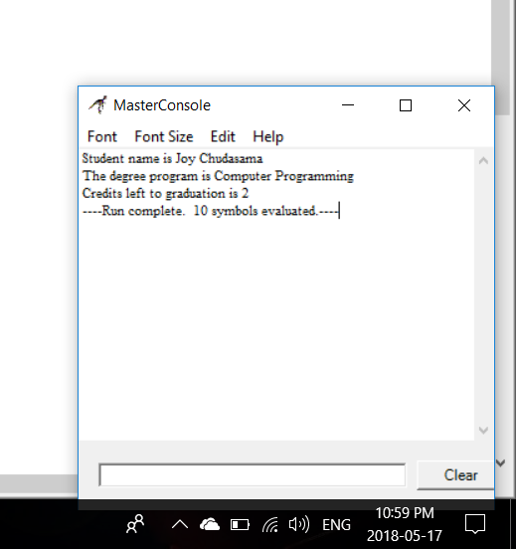
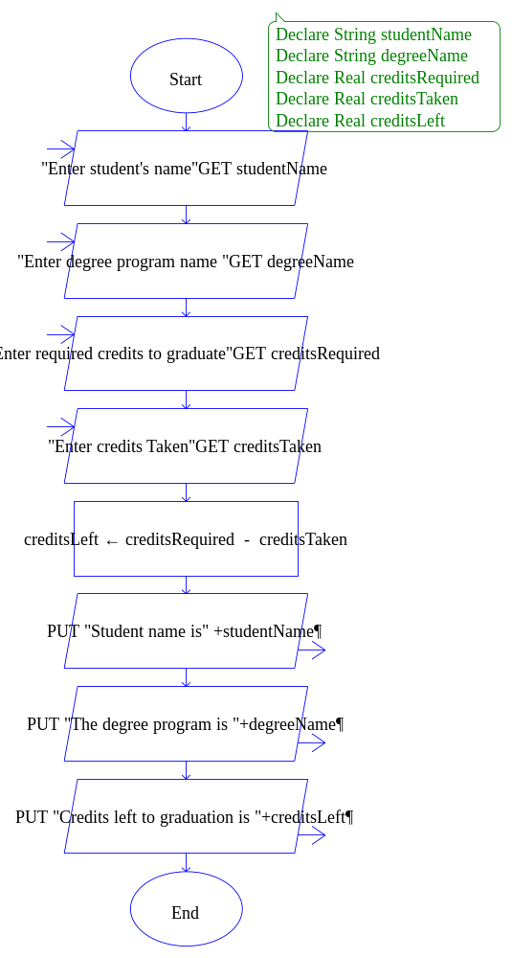

This lab requires you to translate your work in the pseudocode and flowchart to actual code using Python. Read the following program prior to completing the lab.
Critical Review

Comments in Python are preceded by the # sign.

Input of strings into a variable is done using the raw_input function. This function converts the input to a series of characters so they can be used later in the program. This is often written as an equation such as stringVariable = raw_input(‘Enter a word.’).

Input of numeric values into a variable is done using the input function. The method of input is similar to string input. For example, realVariable = input(“Enter a decimal value.’).

Equations are written similarly to the method used in pseudocode, but without the Set keyword. For example total = apples + oranges.

Complex formulas should use parentheses to group processes. In addition, if input values are taken in as integers, but will be used to calculate a decimal value, they must be converted to real values. For example average = (test1 + test2) / 2.

To display information to the screen, the print command is used with the string, which is written within single quotation marks. If the value of a variable needs to displayed after the string, a comma separates the two. For example, print ‘The average is’, average.

Help Video: Double click the file to view video

Write a program that will take in basic information from a student, including student name, degree name, number of credits taken so far, and the total number of credits required in the degree program. The program will then calculate how many credits are needed to graduate. Display should include the student name, the degree name, and credits left to graduate.

Step 1: Examine the following line of code. What do you expect as output to the screen?

studentName = input(‘Enter student name. ‘)

Enter student name.

Step 2: Examine the following line of code. What type of value do you expect the user of the program to enter?

creditsDegree = input(‘Enter credits required for degree.’

Numeric value

Step 3: If the user of the program types Bill Jones to the question in Step 1, what do you expect the output to the screen to be when the following line of code processes?

print (“The student's name is”, studentName)

It will show error because there should be “+studentName” instead of “studentName “

Step 4: Examine the following line of code. If the program requires 63 credits, and the student has 20 left, what do you expect the output to the screen to be?

print ('The program requires', creditsDegree, ‘credits and they have taken', creditsTaken, 'credits so far.')

The program requires 63 credits and they have taken 43 credits so far.

Step 5: Start the IDLE Environment for Python. If the Edit window for entering code does not come up, go to Options, Configure IDLE, click on the General tab, and under Startup Preferences select Open Edit Window. Close and reopen the Environment. Prior to entering code, save your file by clicking on File and then Save. Select your location and save this file as Lab1-4.py. Be sure to include the .py extension.

Step 6: Code should start with documentation. Document the first few lines of your program to include your name, the date, and a brief description of what the program does. Each line that you want to comment out must begin with a # sign. For example:

#Sally Smith
#January 15
#This program ...

Step7: After documentation, enter the following line of code into your program.

studentName = raw_input(‘Enter student name. ’)

Step 8: On the menu, select Run and then Run Module. Observe your program in action. If you get a syntax error, you must fix it before you are able to run your program. Click OK and review the highlighted syntax error to fix it.

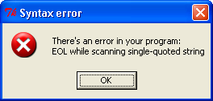

Step 9: Repeat Step 8, but change the statement so that it asks the user to enter their degree name. It is up to you whether you want to repeat Step 9 each time you code a line. It is recommended for beginning programmers so they can immediately identify syntax errors. Also, one syntax error at a time seems better than many all at once.

Step 10: Next, you should write the code that will ask the user how many credits are required in the degree. This can be done using the input function since it is a numeric value. Enter the following line of code into your program.

creditsDegree = input(‘Enter the number of credits required for the degree. ‘)

Step 11: Repeat Step 11 but change the statement so that it asks the user to enter the number of credits they have taken so far.

Step 12: Next, add your calculation. This is done very simply with the following code.

creditsLeft = creditsDegree – creditsTaken

Step 13: Add the following line of code to your program.

print ('The student's name is', studentName)

Step 14: If you have not tested your program in a while, now is a good time to try it out. Go to Run and Run Module and observe what happens. SYNTAX ERROR!

Step 15: While nothing stands out as being wrong in Step 15, notice that the word student’s is actually causing the problem. To the language, the apostrophe looks as if it is the end of the statement. Since it is not, it must be quoted out by putting a \ in front of it. Change the line to the following.

print (“The student's name is”, studentName)

Step 16: Finish your code by printing the remaining of the requested statements. Your final output might look like the following.

Enter student name. Bill Jones
Enter degree name. Computer Programming
Enter the number of credits required for the degree. 63
Enter the number of credits taken so far. 24

The student's name is Bill Jones
The degree name is Computer Programming
There are 39.0 credits left until graduation.

Step 17: When your code is complete and runs properly, on the Menu, go to Edit and then Select All, then Edit and Copy. Paste the code below.

PASTE CODE HERE

#Name : Joy Chudasama
#Date : 18th May,2018
#Program : Computer Programming
studentName=input("Enter student name :")
studentDegree=input("Enter the name of degree program :")
creditsDegree=int(input("Enter the number of credits required for the degree : "))
creditsTaken=int(input("Enter the credits taken so far :"))
creditsLeft = creditsDegree - creditsTaken
print("\n The student name is "+studentName)
print(" Student's degree program is "+studentDegree)
print(" There are %d credits left until graduation"%(creditsLeft))

Lab 1.5 – Programming Challenge 1 – Team Average

Write the Algorithm, Pseudocode, Flowchart, and Python code for the following programming problem.

Help Video: Double click the file to view video

Team Average

A college wants you to write a program for them that will calculate the average number of wins for their football team over the past five years. The user of the program should be able to enter the number of wins each year. The program will calculate the average number of wins during that five year period and display that information to the screen.

The Algorithm

TYPE ALGORITHM HERE

- Take input of all years’ wins
- Calculate Average
- Dsiplay Average to the screen

The Pseudocode

TYPE PSEUDOCODE HERE

- Declare Real year1Wins
- Declare Real year2Wins
- Declare Real year3Wins
- Declare Real year4Wins
- Declare Real year5Wins
- Declare Real average

The Flowchart

PASTE FLOWCHART HERE

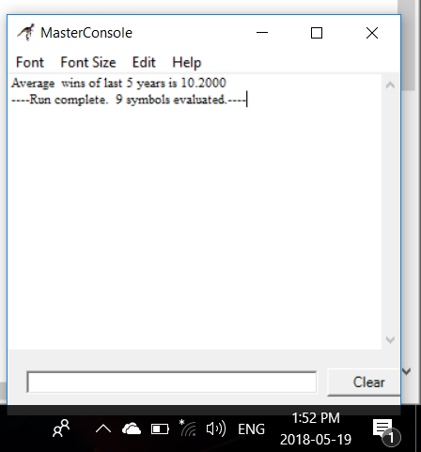
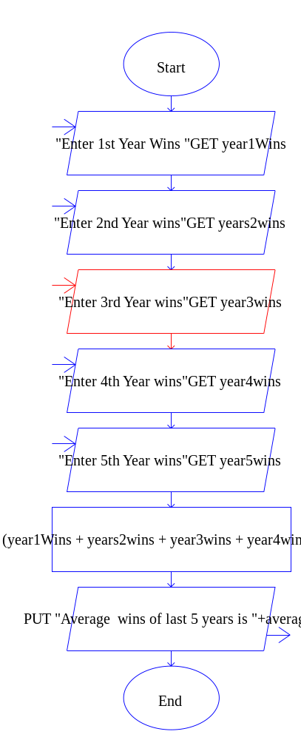
The Python Code

PASTE CODE HERE

teamName=input("Enter the name of your team :")
year1wins=int(input("Enter the numbers of win during 1st year :"))
year2wins=int(input("Enter the numbers of win during 2nd year :"))
year3wins=int(input("Enter the numbers of win during 3rd year :"))
year4wins=int(input("Enter the numbers of win during 4th year :"))
year5wins=int(input("Enter the numbers of win during 5th year :"))
average = (year1wins+year2wins+year3wins+year4wins+year5wins)/5
print("\n The "+teamName+"'s average number of wins in past 5 years are %d "%(average))

Lab 1.6 – Programming Challenge 2 – Pedometer Calculator

Write the Algorithm, Pseudocode, Flowchart, and Python code for the following programming problem.

Help Video: Double click the file to view video

Pedometer Calculator

A dietician wants you to write a program that will calculate the number of calories a person can lose by walking at a slow pace for a mile; however, the user will have only the distance given by a pedometer, which is measured in steps and not miles. Assume each mile a person walks is equivalent to 2000 steps, and that for every mile walked, a person loses 65 calories. Allow the user of the program to enter the number of steps taken throughout the day. The program will calculate the distance in miles and the number of calories lost. The user of the program should also be able to enter the day of the week the data is being calculated for. The day of the week, the distance in miles, and the calories lost should then be displayed to the screen.

The Algorithm

TYPE ALGORITHM HERE

- Take input from user of day of the week and number of steps he/she walked throughout that day
- Calculate Miles per day and Calories he/she burned on given day
- Display miles he/she walked and burned calories

The Pseudocode

TYPE PSEUDOCODE HERE

- Declare String dayOfWeek
- Declare Float milessPerDay
- Declare Float caloriesBurned

The Flowchart

PASTE FLOWCHART HERE
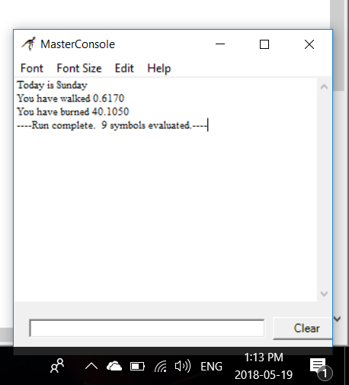
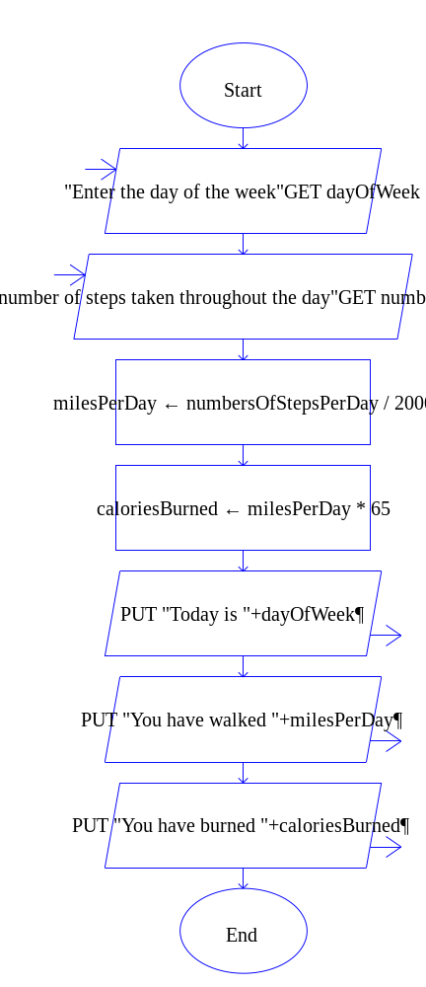

The Python Code

PASTE CODE HERE

dayOfWeek = input("Enter the day of the weeek :")
numberOfStepsPerDay = float(input("Enter the number of steps taken throuout the day :"))
milesPerDay = numberOfStepsPerDay/2000
caloriesBurned = milesPerDay * 65
print("\n>>>>>>>>>>>>>>>>>>>>>>>>>>>>>>>>>>>>>>>>>>>>>>>>>>>>>>>>>>>>>>>>>>>>>>>>>>>>>")
print(" Today is "+dayOfWeek+" and you have walked %.2f miles and burned %.2f calories."%(milesPerDay,caloriesBurned))
print("<<<<<<<<<<<<<<<<<<<<<<<<<<<<<<<<<<<<<<<<<<<<<<<<<<<<<<<<<<<<<<<<<<<<<<<<<<<<<<")

